PROPERTY FEASIBILITY & STRATEGY REPORT

Unit 25 / 316 Parramatta Road
Burwood NSW 2134
Capital-growth outlook, planning-uplift potential, development & collective-sale feasibility, market impact, and tax / ownership strategy — assessed against the Burwood North Metro rezoning, the Parramatta Road Corridor strategy, and Sydney Metro West.
Prepared for | Tao Ling (owner-occupier)
Subject property | Unit 25 / 316 Parramatta Road, Burwood NSW 2134
Current asking price | $900,000
Report date | June 2026
Status of controls | Burwood North rezoning post-exhibition; finalisation expected 2026

Important — please read first
• This report is general information only. It is not financial product advice, tax advice, legal advice, a property valuation, or town-planning advice, and it does not take account of your full personal circumstances.
• Planning controls described here were on public exhibition and not yet finalised at the report date. Site-specific facts (exact strata plan, lot count, site area, zoning, height/FSR, overlays, and precinct membership) are stated as to be confirmed and must be verified on the NSW Planning Portal / ePlanning Spatial Viewer and via NSW Land Registry Services before you rely on them.
• Dollar figures in the scenario sections are illustrative decision bands, not forecasts or valuations. Before acting, take the questions flagged throughout to a registered tax agent, a solicitor / licensed conveyancer, a licensed financial adviser, and a local selling agent / valuer.

Executive summary

You own and live in a one-bedroom apartment at Unit 25 / 316 Parramatta Road, Burwood, now listed at $900,000. The question is whether to sell now, hold, rent, or wait for a potential site / collective sale — against three large, genuine tailwinds converging on this exact location.
The three tailwinds (all verified, public)
- Burwood North Metro Precinct rezoning — a NSW Government-led rezoning of the 113-hectare area within ~800 m of the future Burwood North Metro station. It was on public exhibition 10 March – 10 April 2026, proposes building heights of 8 to 42 storeys (≈28–140 m), around 18,300 new homes, and 5–10% affordable housing in perpetuity. Finalisation is expected in 2026.
- Sydney Metro West — a new underground rail line targeting 2032, with a confirmed station at Burwood North. This is the single biggest driver of long-term land value in the precinct.
- Parramatta Road Corridor Urban Transformation Strategy (PRCUTS) — the 30-year state strategy whose Burwood–Concord precinct sits along your road frontage, envisaging large-scale renewal (Stage 1 controls already in force since December 2022).
What it means for you — the short version
- Your apartment sits in the right place at the right time. A well-located, modern 1-bedroom unit a short walk from a future Metro station, inside a precinct adding ~18,300 homes and a new town centre, has a genuine amenity-driven growth story — that is the core of the case here.
- A development / collective-sale premium is a long-dated tail, not a near-term play. Your block ('SOL Apartments', a modern ~54-unit complex) is not an old walk-up that developers rush to assemble — new buildings are rarely demolished. A site sale would also need 75% of owners to agree and a Land and Environment Court order. Treat it as remote optionality, not a plan.
- The main-residence CGT exemption is your biggest financial lever. Because you have lived in the apartment, a sale today may be fully or largely CGT-free. The longer you rent it out, the more that exemption can erode. This timing question is worth a paid hour with a registered tax agent before any decision.

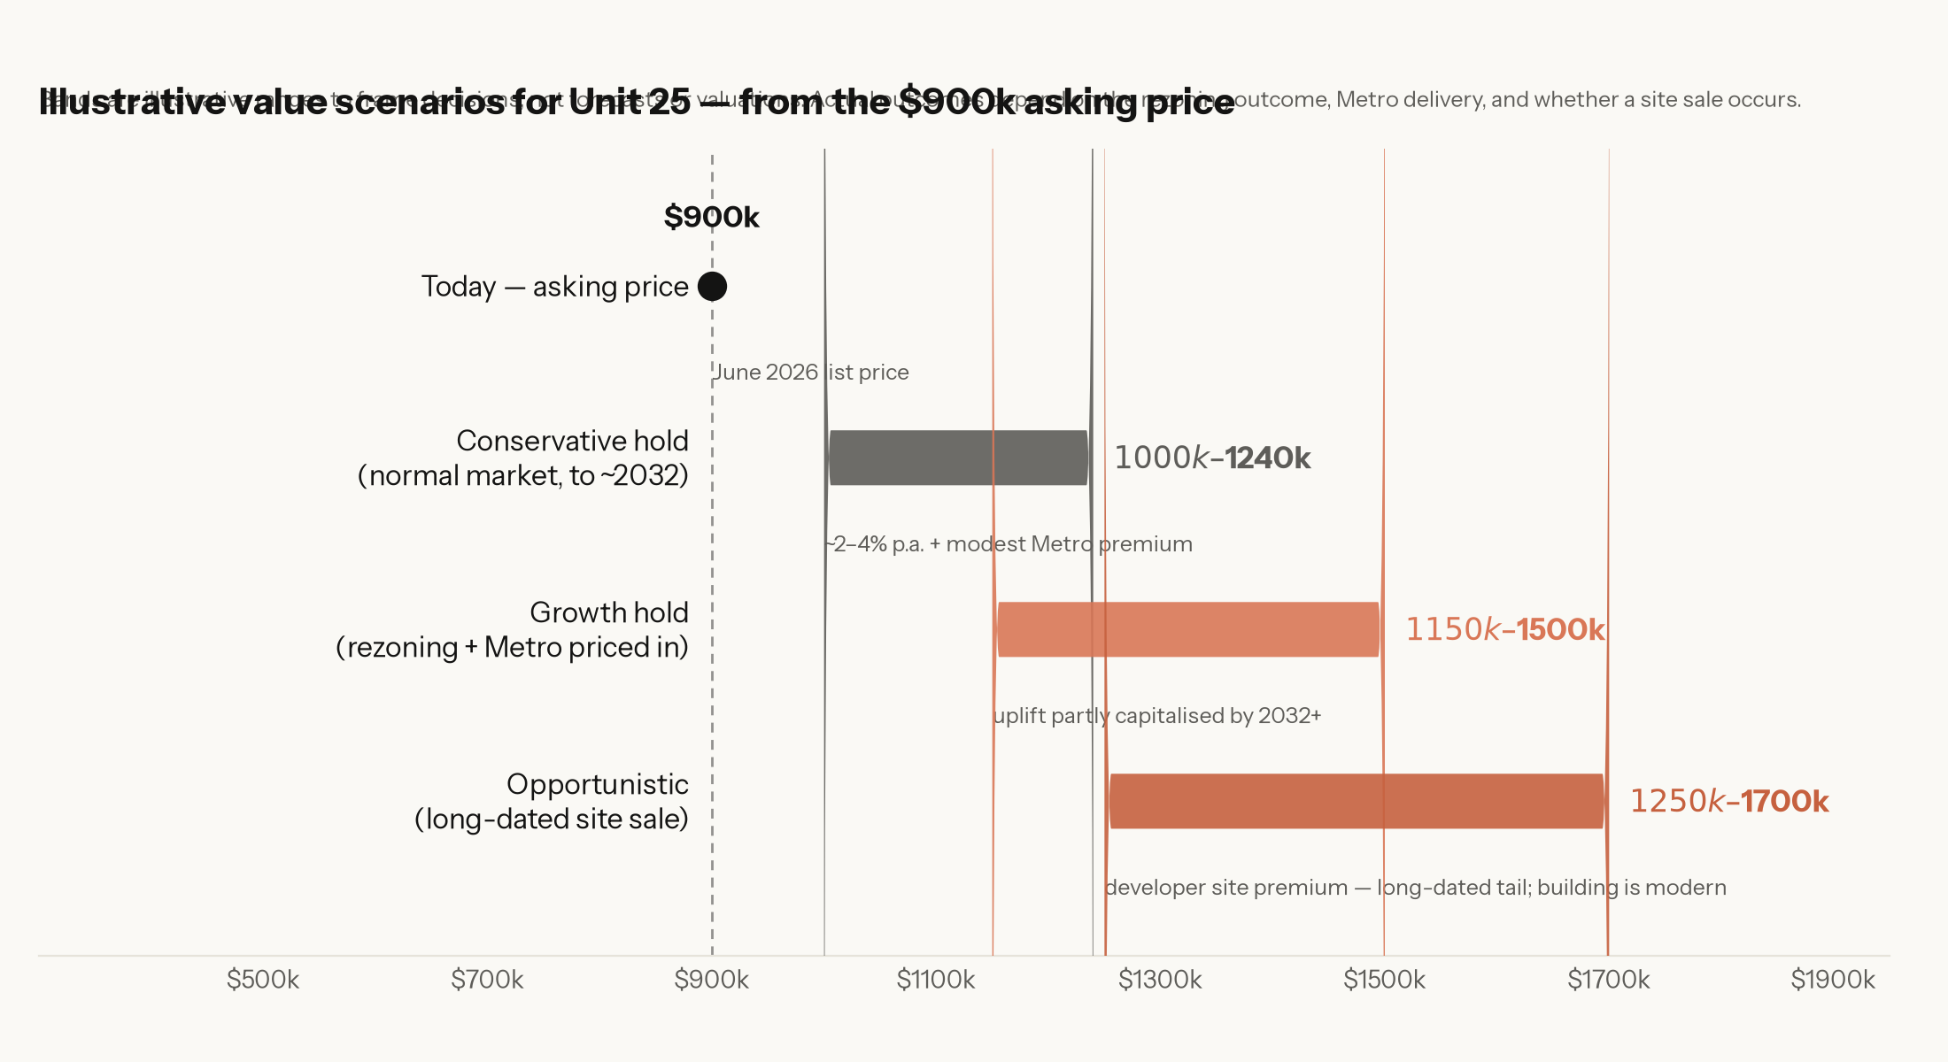
Illustrative value scenarios — bands frame decisions; they are not forecasts or valuations.
Bottom line by scenario
If your priority is… | Then the lead action is…
Certainty & a clean CGT outcome (Conservative) | Confirm the main-residence exemption with a tax agent; sell at or near the $900k mark while it is CGT-advantaged. Don't bank on uplift you can't control.
Maximising long-run value (Growth) | Hold and rent within the CGT 6-year absence rule; re-test the market as the rezoning finalises (2026) and again as Metro West nears (2030–32).
A long-shot development premium (Opportunistic) | Because the building is modern, a site sale is a long-dated tail, not a near-term play. Stay reachable to site-assembly interest, but build no plan around it.

Each scenario, with trigger points and the specific professional advice to obtain, is set out in Section F.

A. Property identification & verification

Your enquiry gave the postcode as 2135. Public listing and building-profile records for 316 Parramatta Road consistently show the postcode 2134 (Burwood), so this report uses Burwood NSW 2134. The building is marketed as 'SOL Apartments' — a modern complex of about 54 units described as brand-new luxury apartments. That the building is modern, not an old walk-up, is an important fact for Section C. Please confirm the details below on a rates notice and your strata records.
What is verified vs. what you must confirm
Attribute | Position in this report | How to confirm
Street address | Unit 25 / 316 Parramatta Road, Burwood | Rates notice / strata roll
Postcode | 2134 (not 2135) | Australia Post / rates notice
Building | 'SOL Apartments' — modern luxury complex | Strata records / marketing
Building age | Modern / recently built (not an old block) | Strata roll / occupation certificate
Local government area | Burwood Council (State precinct straddles Burwood + City of Canada Bay) | ePlanning Spatial Viewer (LGA layer)
Strata plan (SP) number | To be confirmed | NSW Land Registry Services title search
Number of lots in scheme | ≈54 (Domain building profile) — confirm exactly | Strata roll / strata manager
Site area & frontage | To be confirmed | Title / deposited plan
Current zoning | To be confirmed (Parramatta Rd frontage — likely a centre/mixed-use or enterprise-corridor zone under Burwood LEP 2012) | ePlanning Spatial Viewer (Land Zoning)
Height / FSR controls | To be confirmed for this lot | Spatial Viewer (HOB + FSR layers)
Overlays (heritage, flood, road-widening, acquisition) | To be confirmed | Spatial Viewer + Section 10.7 planning certificate
Precinct membership | On the Parramatta Rd frontage near the station — confirm side & boundary | Burwood North exhibition maps / Spatial Viewer

Why the LGA and precinct-boundary checks matter. The future Burwood North Metro station sits at the corner of Burwood Road and Parramatta Road, and the rezoning amends both the Burwood Local Environmental Plan 2012 and the Canada Bay LEP 2013, because the State-led precinct straddles the two councils along Parramatta Road. Burwood Council's own masterplan area runs south of Parramatta Road (bounded by Parramatta Road to the north, Shaftesbury Road east, Park Road west, and Burwood Park to the south). A Parramatta Road frontage address can fall on either side / either council, so confirming which side your lot is on — and whether it is inside the exhibited boundary — is the single most valuable site fact to nail down, because it determines how much extra density your land may carry. A Section 10.7 planning certificate from the relevant council and the exhibited precinct map are the authoritative sources.
Location & access (to confirm by measurement)
- Burwood North Metro station (future, ~2032) — the precinct is defined as the ~800 m walkable catchment around this station; a Parramatta Road address is typically well within it.
- Burwood heavy-rail station & Westfield Burwood — the established Burwood town centre and T-line station sit a short distance south, giving the site two rail options once Metro opens.
- Five Dock Metro station (future, ~2032) — the next station west, anchoring a separate Canada Bay rezoning used as a comparable in Section B.
- Schools, retail and employment — Burwood is an established major centre; confirm exact walking distances for your listing and for any buyer.
Take to your conveyancer / planner
• Order a title search and Section 10.7(2) and (5) planning certificate for the lot — these confirm zoning, applicable LEP, and any road-widening / acquisition or heritage affectation.
• Ask them to confirm in writing whether the lot falls inside the exhibited Burwood North precinct boundary, and the height and FSR proposed for it.
• Confirm the strata plan number and total lot count — this drives the collective-sale maths in Section C.

B. Planning-uplift potential

Burwood North Metro Precinct — what is proposed
This is a State-led rezoning (run by the NSW Department of Planning, Housing and Infrastructure rather than the council), reflecting how strategically important the government considers the Metro catchment. Key parameters from the exhibited package:
Control | Proposed (exhibited 2026) | Significance
Precinct size | ≈113 ha, ~800 m around Burwood North Metro station | Defines who is 'in'
Building heights | 8 to 42 storeys (≈28–140 m), tiered by location | Tallest near the station; a step-change from today's low/mid-rise
New homes | ≈18,300 (up ~3,000 on the 2025 figure) | Large uplift in permissible density
Affordable housing | 5–10%, retained in perpetuity | A cost/levy on redevelopment feasibility
Instruments amended | Burwood LEP 2012 + Canada Bay LEP 2013 | Two-council precinct
Status | Exhibited 10 Mar – 10 Apr 2026; finalisation expected 2026 | Submissions being considered now

How uplift creates value. When permissible height and floor-space ratio rise, a site can lawfully hold far more saleable floor area. That extra development capacity is what a developer pays for — which is why rezoned, Metro-adjacent land can be worth materially more as a development site than as the sum of its existing apartments. The catch is that the uplift has to actually apply to your lot, and the numbers have to stack up for a developer (see Section C).
How likely is the uplift?
- Direction of travel is strong. The rezoning is State-led, already exhibited, tied to a funded Metro station, and reinforced by the separate PRCUTS corridor strategy. Government messaging frames it as central to Sydney's housing supply.
- But it is not yet law. Until the amended LEPs are made, heights and FSR can change at finalisation in response to submissions. Treat current numbers as strong indicative, not guaranteed.
- Site-specific risk remains. Even within a precinct, individual lots get different heights/FSR, and some frontages carry setbacks, active-frontage rules, or road-widening lines that reduce developable area.
Comparator — Five Dock precinct (City of Canada Bay)
Five Dock, the next Metro West station west, is being rezoned in parallel under planning proposal PP2025/0003 (early 2026): an expanded MU1 Mixed Use core with R4 High Density Residential surrounds, with base heights in the order of 8.5–17 m before bonus provisions. It is a useful read-across because it shows the same Metro-led uplift logic being applied one station away — but note Burwood North's exhibited heights (up to ~42 storeys) are substantially greater, reflecting its role as a larger town-centre precinct. The Burwood catchment therefore carries the higher potential uplift of the two.
The Parramatta Road corridor (PRCUTS)
Underneath the Metro rezoning sits the longer-running Parramatta Road Corridor Urban Transformation Strategy — a 30-year plan identifying eight renewal precincts, including Burwood–Concord on your frontage, and envisaging up to 27,000 homes and 50,000 jobs corridor-wide. Stage 1 controls were made into law in December 2022 (DCP adopted March 2023). For you this means main-road renewal here is not a single announcement — it is a layered, decade-plus government commitment, which strengthens the long-term thesis even if any single step slips.

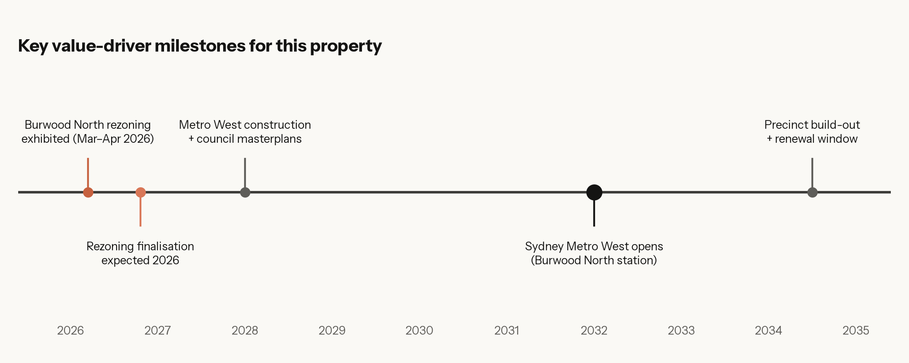
Verified planning and Metro milestones shaping value over the next decade.
Take to your town planner
• Obtain the exhibited height and FSR maps for the precinct and confirm the figures that apply to your lot specifically.
• Ask whether your frontage carries road-widening, active-frontage, or setback requirements that would reduce a developer's usable area.
• Ask for a view on finalisation timing and the risk of change between exhibition and the made LEP.

C. Development & collective-sale potential

Read this first — your building is modern
• 316 Parramatta Road ('SOL Apartments') is a modern, recently-built complex of ~54 units, not an old walk-up. Developers assemble and demolish *old, under-developed* buildings — a new building that has already used much of its site's value is rarely a near-term redevelopment target. So while the law below makes a collective sale possible, for this building it is a long-dated tail, not a live opportunity. The realistic upside here is Metro-driven amenity growth of a modern apartment (hold), covered in Sections B and D.

Could a developer buy the whole site?
For a developer to redevelop your building, they generally need to acquire every lot in the strata scheme (or enough of it, via the collective-sale process below). Whether they want to depends on:
- Uplift — how much extra floor space the rezoning grants the site beyond what is already built. A modern complex has often already used much of its permissible floor space, leaving less residual headroom for a developer to chase.
- Building age & condition — older, lower-rise blocks are far more attractive to replace than a new building. This is the decisive factor against your block being a near-term target.
- Site geometry & amalgamation — whether the block alone is big enough, or must be combined with neighbours to make a viable tower footprint.
- Numbers — land cost (what owners demand — high for new stock) versus end values, construction cost, the affordable-housing requirement, and contributions.
The NSW collective-sale (strata renewal) process
If owners want to sell as a block to capture a development premium, NSW law provides a pathway under Part 10 of the Strata Schemes Development Act 2015 (in force since 30 November 2016):
Step | What happens | Threshold / safeguard
1. Proposal | A strata renewal proposal (e.g. a developer offer) is given to the owners corporation | Any owner or outsider can initiate
2. Renewal committee | Owners form a committee to investigate and prepare a strata renewal plan | Owners corporation resolution
3. Plan support | Owners are asked to support the plan | At least 75% of lots must support it
4. Court approval | If some owners dissent, the owners corporation applies to the Land and Environment Court | LEC order required
5. Court test | The Court checks the plan is fair | Must be 'just and equitable'; every owner gets at least market (compensation) value
6. Completion | Sale/redevelopment proceeds, owners are paid out | Independent valuations essential

What this means in practice. The 75% threshold makes collective sale possible without unanimous agreement, but the Court step makes it slow and rigorous — these processes commonly run two to four years and have succeeded even for large schemes (a 159-lot scheme was approved in 2019). The premium can be real, but it is contingent and illiquid: you cannot force it, time it, or rely on it for your own plans.
Your options compared
Path | Upside | Downside / risk | Control you have
Sell individually now | Liquid; clean CGT position; certainty | Forgo any future uplift premium | Full
Hold & rent | Keep optionality; rental income; ride growth | Market & strata risk; CGT exemption erodes over time | Full
Collective / site sale | Potential premium over individual value | Needs 75% + Court; 2–4 yrs; may never happen | Shared (low)
Option / put-and-call to a developer | Lock a future price; some certainty | Tie up the asset; complex terms | Moderate
Development agreement / JV | Share in end-development profit | High risk/complexity; not realistic for a single lot owner | Low

Timing windows
- Now → finalisation (2026): speculation builds as the rezoning is made. Site-assembly interest and early developer/agent approaches can appear in this window.
- Finalisation → Metro construction (2026–2030): controls are certain; feasibility sharpens; amalgamation activity typically intensifies.
- Metro opening onward (2032+): maximum amenity, but also maximum new supply coming on line — good for land value, mixed for an individual 1-bed unit competing against new stock.
Take to a strata-experienced solicitor + selling agent
• Ask a collective-sale solicitor to explain the Part 10 process for your scheme and what a fair compensation value would look like.
• Ask a local agent who is active in site assembly whether developers are already approaching your block or street, and what premium (if any) collective sales nearby have achieved.
• Do not sign an option, heads of agreement, or renewal proposal without independent legal advice — these can bind you cheaply and early.

D. Market-impact analysis

Burwood units currently sit around a median of $790k–$880k, rent at roughly $720–$800 per week, and yield about 4.7% (early-2026 market data; confirm with a local agent for your exact unit type). Your $900k asking price is therefore at the upper end of the unit market — consistent with a renovated/well-located 1-bed, and with buyers already pricing in some Metro/rezoning optimism.
Short term (0–3 years)
- Catalyst: rezoning finalisation (2026) and continued Metro West works.
- Likely effect: supportive sentiment and headline attention; values for well-located stock firm to modestly higher. But main-road 1-bed apartments can lag in softer markets, and rising interest rates or new-supply announcements can offset rezoning optimism.
- Watch: the final heights/FSR, any first developer site-assembly in your street, and unit days-on-market in Burwood.
Medium term (3–7 years)
- Catalyst: Metro West construction visibly progressing; council masterplans and DCPs landing; first redevelopment sites being assembled.
- Likely effect: this is often where land value (development potential) starts to out-perform dwelling value (the existing flat). If your block becomes an assembly target, the site-sale optionality is most live in this window.
- Watch: construction disruption along Parramatta Road can temporarily dampen rents/amenity even as long-term value builds.
Long term (7–15 years)
- Catalyst: Sydney Metro West opens (~2032); precinct build-out; two rail options at Burwood.
- Likely effect: the strongest structural case for capital growth — genuine Metro-led, town-centre uplift. Counterweight: thousands of new apartments completing in the same precinct means an older 1-bed competes against abundant new stock, which can cap price growth and rental tension for that specific dwelling even as land values rise.
- Net: long-term land thesis strong; long-term single-dwelling thesis good but supply-sensitive. Because the building is modern, your realistic exposure is to the dwelling thesis (amenity-driven growth of a quality apartment), not the site-redevelopment one — which is why a clear-eyed hold-or-sell decision matters more here than waiting for a developer.

E. Tax & ownership strategy

This section is general information, not tax advice
• CGT and the main-residence exemption are fact-specific and rule-heavy. The notes below are general and current understanding only. Confirm everything with a registered tax agent before acting — the right structure can be worth tens of thousands of dollars.

The main-residence exemption — your biggest lever
Because the apartment has been your home, Australia's CGT main-residence exemption may make a sale fully or largely CGT-free. In broad terms a dwelling can be fully exempt where it was your main residence for the whole ownership period, sits on 2 hectares or less, and was not used to produce income. Where you have held it for more than 12 months, the 50% CGT discount also applies to any taxable portion.
What can complicate or reduce the exemption
- Renting it out. Once the dwelling produces income, the exemption can be affected. The 'absence rule' can keep a former home exempt for up to 6 years while rented (and potentially indefinitely if it is not income-producing) — if you don't claim another property as your main residence for that time. Exceeding 6 years of renting typically introduces a partial CGT liability.
- The 'first used to produce income' rule. If you first rent out a home that was previously your residence, a special rule can reset the cost base to market value at that date — which changes the CGT maths significantly.
- Periods before it was your home, or only partial occupation. Any period it was not your main residence generally produces a pro-rata taxable portion.
- Using part of the home for income (e.g. a home business or renting a room) can reduce the exemption proportionately.
Illustrative tax outcomes across the scenarios
Scenario | Typical CGT exposure (general, confirm) | Implication
Sell now, lived in it throughout | Likely full exemption — little/no CGT | Cleanest outcome; preserves the benefit you've earned
Rent for ≤6 yrs (absence rule), then sell | Often still fully exempt if no other main residence claimed | Keeps optionality without losing the exemption — if done correctly
Rent for >6 yrs, then sell | Partial CGT likely; 50% discount on the taxable part | Each extra year of renting can add to the bill
Collective / site sale later | Depends on use in the interim + how proceeds are characterised | Get advice before signing anything — structure matters

Documents to keep (whatever you decide)
- Purchase contract, settlement statement, and stamp duty records.
- Records of every period the property was your home vs. rented (dates, leases, agent statements).
- Receipts for capital improvements (these can lift the cost base and reduce CGT on any taxable portion).
- If you ever rent it: a market valuation at the date it is first rented (for the 'first used to produce income' rule).
- Strata records, and any developer / renewal correspondence.
Questions for your registered tax agent
• Given my actual occupation dates, is a sale today fully CGT-exempt?
• If I rent it out, how long can I do so under the 6-year absence rule without losing the exemption, and what do I have to be careful of?
• Would I benefit from a market valuation now in case I later rent it (the 'first used to produce income' rule)?
• How would the proceeds of a collective / site sale be taxed, and does timing change the outcome?
• Are there superannuation or income-timing strategies that interact with a sale year?

F. Recommendation under three scenarios

There is no single 'right' answer — it depends on your appetite for certainty versus upside, and on facts only your advisers can confirm. The three scenarios below are decision frameworks, each with concrete actions, trigger points, and the advice to obtain.
Scenario 1 — Conservative (prioritise certainty & CGT efficiency)
- Action: confirm the main-residence exemption with a tax agent, then sell at or near $900k while the position is CGT-advantaged and buyer optimism is already in the price.
- Trigger to act now: you value a clean, liquid outcome over uncertain future upside, or you need the capital.
- Price to justify holding instead: if an agent shows recent comparable 1-beds clearing well above ~$950k–$1.0m, reconsider — the market may already be rewarding patience.
- Advice needed: registered tax agent (exemption), selling agent (true clearing price).
- Key risk: selling just before a rezoning-driven step-up. Mitigant: the exemption and certainty have real value today, and uplift is not guaranteed to reach your lot.
Scenario 2 — Growth-focused (hold for the Metro / rezoning thesis)
- Action: hold, and if you move out, rent within the 6-year absence rule so the CGT exemption is preserved; re-test value at two milestones — rezoning finalisation (2026) and as Metro West nears (2030–32).
- Trigger to act: rezoning finalises with strong height/FSR confirmed for your lot; comparable values rising.
- Price premium to sell into: a market or off-market offer materially above the prevailing unit median (e.g. a 20%+ premium to comparable 1-beds) — especially if it reflects development interest rather than dwelling value.
- Advice needed: tax agent (absence-rule mechanics + valuation timing), property manager, agent for periodic appraisals.
- Key risk: new-supply competition caps growth for an older 1-bed, and renting too long erodes the exemption. Mitigant: the 6-year rule and disciplined milestone reviews.
Scenario 3 — Opportunistic (the long-shot development premium)
- Reality check first: because the building is modern, a site / collective sale is a long-dated tail, not a near-term play — new buildings are rarely demolished. Do not build a plan around it; this scenario is about staying reachable, not waiting.
- Action: hold on the Section-2 growth logic, and simply stay visible to any site-assembly interest. Take any unsolicited approach to a collective-sale solicitor before responding.
- Trigger to even consider: a credible, unsolicited developer or renewal proposal for your block or street — which, for a new building, would be unusual.
- Premium to justify selling: an offer that clearly beats an individual after-tax sale; insist on independent valuation and legal review before signing anything.
- Advice needed: strata-experienced solicitor (Part 10 process), independent valuer, tax agent.
- Key risk: anchoring on a premium that, for a modern building, may never come. Mitigant: treat the Section-2 hold (or a clean Section-1 sale) as the real plan; this is only upside if it ever appears.
How to choose
Most owner-occupiers in your position land on a blend: confirm the CGT position immediately (cheap, high-value), keep the property at least until the rezoning finalises in 2026 (low cost, preserves optionality via the absence rule), and stay reachable to site-assembly interest without committing. Sell decisively if (a) the after-tax price today beats your realistic hold case, or (b) a genuine development premium appears. The one thing not to do is make an irreversible decision before a tax agent has confirmed your exemption and a planner has confirmed what the rezoning actually does to your lot.

Sources & verification trail

All planning, Metro, and legislative facts in this report are drawn from public sources current to June 2026. Site-specific facts marked 'to be confirmed' must be verified before reliance.
- NSW Department of Planning — Burwood North Metro Precinct rezoning (exhibition & ministerial releases): planning.nsw.gov.au; nsw.gov.au/ministerial-releases; planningportal.nsw.gov.au (post-exhibition).
- Sydney Metro West — project overview & 2032 target, Burwood North & Five Dock stations: sydneymetro.info/west.
- City of Canada Bay — Five Dock Precinct planning proposal PP2025/0003: canadabay.nsw.gov.au; collaborate.canadabay.nsw.gov.au.
- Parramatta Road Corridor Urban Transformation Strategy (PRCUTS) — Burwood–Concord precinct; Stage 1 LEP (Dec 2022) / DCP (Mar 2023): planning.nsw.gov.au/plans-for-your-area; landcom.com.au.
- Strata Schemes Development Act 2015 (Part 10, strata renewal / collective sale, 75% + Land and Environment Court): legislation.nsw.gov.au; registrargeneral.nsw.gov.au.
- Burwood unit market data (median, rent, yield — early 2026): yourinvestmentpropertymag.com.au; propertyvalue.com.au; auspropertyinsights.app.
- CGT main-residence exemption, absence rule, 'first used to produce income', 50% discount: ato.gov.au (general guidance — confirm with a registered tax agent).
- Address / postcode (2134) & building profile: domain.com.au building profile for 316 Parramatta Road, Burwood NSW 2134.

End of report. Prepared as a decision-support document for the owner. Take the flagged questions to the relevant registered professionals before acting.

