Market Appraisal
Unit 25 / 316 Parramatta Road, Burwood NSW 2134
2 bed · 2 bath · 1 car apartment · 112 m² · Level 3, north
$865,000 – $955,000
Indicative range · midpoint ~$910,000 · direct comparison · low–moderate confidence

Prepared for: HS Partners Real Estate
Indicative market appraisal — not a certified valuation (see Important notice).
1 Property summary
Property address | Unit 25 / 316 Parramatta Road, Burwood NSW 2134
Real property description | Not supplied in Valura inputs
Zoning | E3
LGA | Burwood Council
Current use | Apartment
Main dwelling | 2 bedroom / 2 bathroom
Car spaces | 1
Total area | 112 m²
Level | 3
Aspect | North
Built about | 2016
Title search sighted | Not supplied in Valura inputs
Heritage issues | Not supplied in Valura inputs
Environmental issues | Not supplied in Valura inputs
Essential repairs | Not supplied in Valura inputs
2 Risk analysis
Risk area | Rating | Basis
Location / neighbourhood | Not rated | No inspected risk rating supplied.
Land / title / planning | Not rated | No inspected risk rating supplied.
Environmental issues | Not rated | No environmental report supplied.
Improvements | Not rated | No structural or inspection rating supplied.
Market direction | Not rated | Estimate confidence: low–moderate.
Market activity | Not rated | Evidence base: 3 selected sales.
Local / regional economy impact | Not rated | No macro risk rating supplied.
Market segment conditions | Not rated | Derived only from selected comparable sales.
3 Valuation & assessments summary
- Interest valued: not supplied in Valura inputs.
- Value component: existing property.
- Indicative appraisal range: $865,000 – $955,000.
- Midpoint: $910,000.
- Method: direct comparison.
- Confidence: low–moderate.
- Rental assessment: not estimated by this template.
- Insurance estimate: not estimated by this template.
- Documents to be sighted: confirm title, contract, strata / body corporate records, and any lender-specific documents before reliance.
4 The land
- Property identification: street address supplied; title / strata plan not supplied.
- Zoning effect: E3; planning effect not independently assessed.
- Location: the address is in Burwood NSW. The recorded LGA is Burwood Council; recorded zoning E3. No amenity, school, transport, or travel-time claims are made without source data.
- Neighbourhood: no inspected neighbourhood commentary supplied beyond the grounded local narrative.
- Site description and access: not supplied in Valura inputs.
- Services: not supplied in Valura inputs.
5 Dwelling description
- Style: apartment.
- Accommodation: 2 bedrooms, 2 bathrooms, 1 car space.
- Internal area: n/a.
- Balcony / outdoor area: n/a.
- Total area: 112 m².
- Main walls, roof, linings, flooring, windows, condition, fixtures & fittings: not supplied in Valura inputs.
6 Ancillary improvements
Not supplied in Valura inputs.
7 Sales evidence & the market
Comparable | Date | Sale price | Adjusted | Beds | Source | Basis
3/16–22 Burwood Road | 2026-03 | $848,000 | $900,000 | 2 | NSW VG PSI | size +6.3%; same-locality
205/9 Carilla Street | 2026-03 | $1,000,000 | $1,035,000 | 2 | NSW VG PSI | size +3.4%; same-locality
202/43 Belmore Street | 2026-03 | $1,080,000 | $1,135,000 | 2 | NSW VG PSI | size +5.0%; same-locality

Config-matched 2-bed Burwood sales (Mar 2026, NSW Valuer General PSI) ran from ~$848k to ~$1.08M (size-adjusted ~$900k–$1.135M). The subject is appraised within this evidence at $865,000 – $955,000. Distance basis: same-locality (not geocoded). All comparables are 2-bath / car n/a in the source.
Map not rendered in the source inputs; comparable locality evidence: Burwood.
8 Additional comments
- The output follows a numbered mortgage-valuation report structure for review, but the current Valura market-appraisal profile is not a certified mortgage valuation.
- Contract, title, strata / body corporate, environmental, building, and inspection documents must be checked outside this template before reliance.
- Sale evidence is limited to 3 selected comparable sales carried in the run evidence.
- ESG, environmental, structural, cladding, and body-corporate issues are not independently assessed by this template.
9 Assumptions, conditions & limitations
- This structural variant is not a JLL-issued report and does not use a JLL logo, liability scheme, or valuer declaration.
- Issuer, valuer, company, brand, and disclaimer text remain controlled by the configured brand registry and compliance profile.
- Use certified-valuation wording only after the valuation compliance profile, inspection capture, sighted-document evidence, and registered-valuer sign-off are implemented and approved.
- Current compliance profile: market-appraisal.
10 Capped liability scheme
Not supplied by Valura. Liability wording must come from the authorised issuer / compliance profile.
Visual evidence
Floorplan
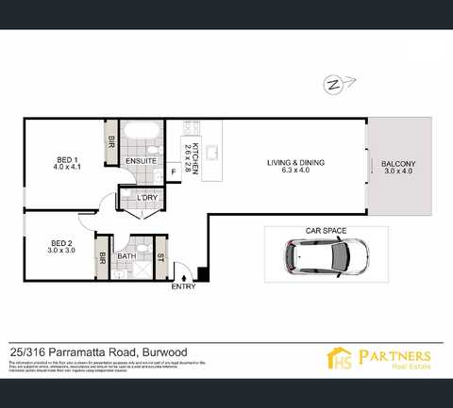
Property floorplan — source: HS Partners listing.
Listing photos
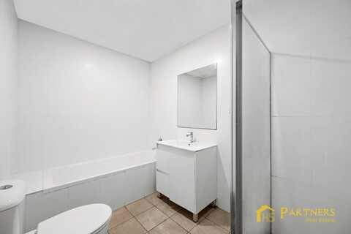
Listing photo 1 — source: HS Partners listing.
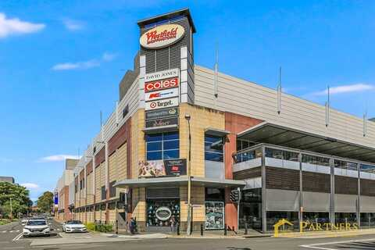
Listing photo 2 — source: HS Partners listing.
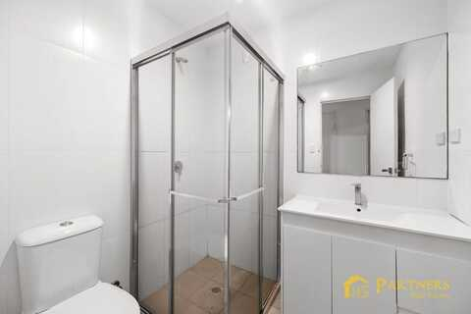
Listing photo 3 — source: HS Partners listing.
Listing photo 4 — source: HS Partners listing.
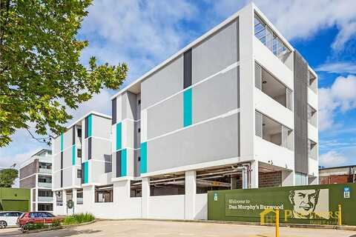
Listing photo 5 — source: HS Partners listing.
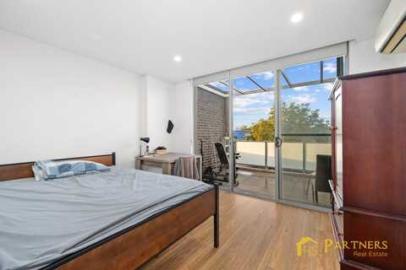
Listing photo 6 — source: HS Partners listing.
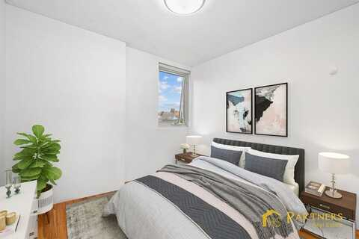
Listing photo 7 — source: HS Partners listing.
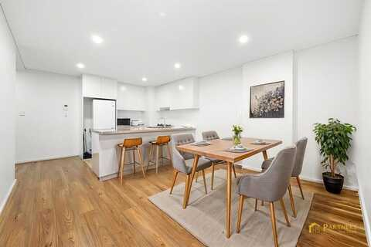
Listing photo 8 — source: HS Partners listing.
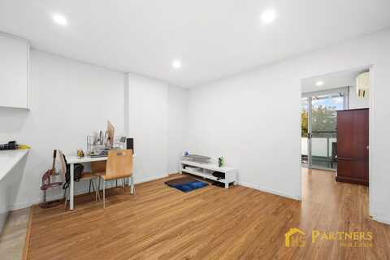
Listing photo 9 — source: HS Partners listing.
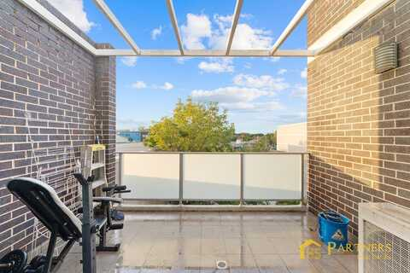
Listing photo 10 — source: HS Partners listing.
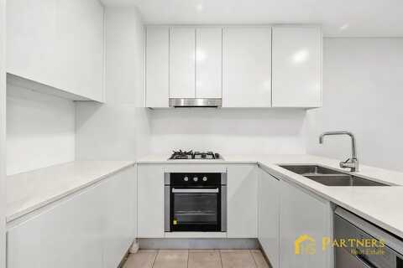
Listing photo 11 — source: HS Partners listing.
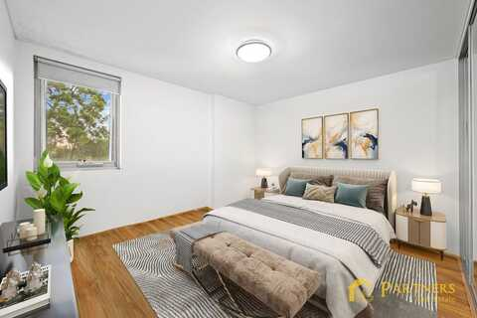
Listing photo 12 — source: HS Partners listing.
Important notice
This market appraisal is an indicative opinion of likely selling range only. It is not a certified valuation, not a mortgage valuation, and not prepared for legal, taxation, lending, or financial-reporting reliance. A certified valuation requires inspection, standards compliance, and sign-off by a registered valuer.
Sources
- NSW Valuer General PSI — comparable sales.
- Manual attribute feed — property attributes.

